Riley Mohr
Created: 4/17/2026
Last Updated: 4/17/2026
ABA Analogue Screening Pipeline
Objective
- A one-paragraph summary of what this pipeline does (e.g., identifying cost-effective ABA analogues).

Software Requirements & Dependencies
List everything the next person needs installed on their machine before they even touch your scripts.
AudoDock Vina: https://vina.scripps.edu/
ChimeraX (for visualization): https://www.cgl.ucsf.edu/chimerax/
ChimeraX direct download link: https://www.cgl.ucsf.edu/chimerax/cgi-bin/secure/chimerax-get.py?file=1.11.1/windows/ChimeraX-1.11.1.exe
Python3 (any version >3.0): https://www.python.org/downloads/
Python imports:
tqdm (for progress bars)
numpy (for math/array operations)
Run these in terminal to install:
pip install tqdm
pip install numpy
You need ChimeraX to run one of the python scripts.

3. The Pipeline Workflow (Your "Table of Contents")
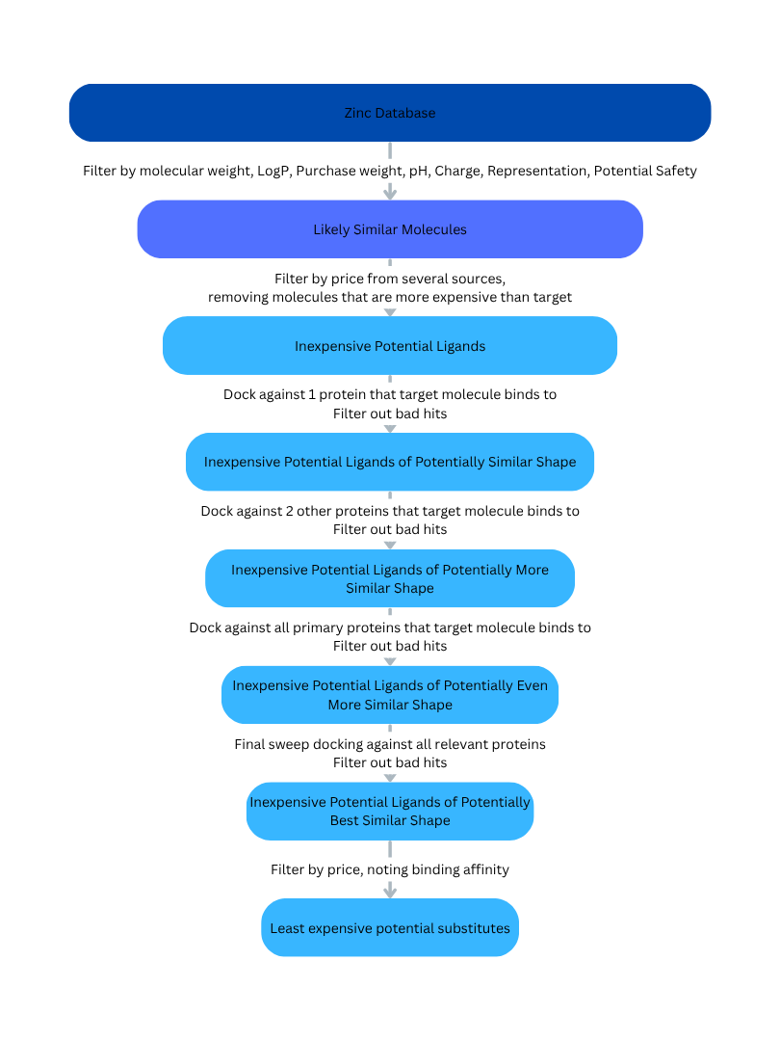

This is the core of the document. Break down the actual order of operations chronologically, explaining what each step does and explicitly stating which .docx file in the protocols2 folder contains the detailed instructions.

Source proteins and target molecule – “1 Source proteins and target molecule.docx”
Filter by molecular statistics – “2 Filter by molecular statistics.docx”
Filter by cost efficiency – “3 Filter by cost efficiency.docx”
Docking filter sweep 1: 1 protein – “4 Docking filter sweep 1.docx”
Docking filter sweep 2: 2-3 proteins – “5 Docking filter sweep 2.docx”
Docking filter sweep 3: All primary proteins – “6 Docking filter sweep 3.docx”
Docking filter sweep 4: All relevant proteins – “7 Docking filter sweep 4.docx”
Final filter by price – “8 Final filter by price.docx”

- Phase 1: Ligand Sourcing & Price Filtering * Description: Pulling ligand structures from the ZINC database and filtering for cost-efficiency prior to docking.
  - Referenced Document: 01_ZINC_Price_Filtering.docx
- Phase 2: Ligand and Receptor Preparation
  - Description: Converting files to the correct formats (like .pdbqt) and setting up the search space/grid box.
  - Referenced Document: 02_Preparation_Protocol.docx
- Phase 3: Docking Execution
  - Description: Running the docking simulations using AutoDock Vina.
  - Referenced Document: 03_AutoDock_Vina_Execution.docx
- Phase 4: Output Analysis & Visualization
  - Description: Analyzing binding affinities and viewing the structural poses in ChimeraX.
  - Referenced Document: 04_ChimeraX_Analysis.docx
4. File Directory Map
Provide a quick visual text map so they know where things are saved on the computer or server.
- protocols2/ - Contains all detailed .docx SOPs.
- scripts/ - Contains your code for filtering or running batches.
- raw_data/ - Where the initial ZINC downloads go.
- results/ - Where the Vina output logs and structures are saved.
5. Troubleshooting & Notes
Leave a section for common errors or quirks in the system (e.g., "If Vina crashes on startup, check that the grid box coordinates are formatted correctly").
Restructuring the pipeline to filter for price before running the heavy computational docking is a very smart optimization that will save a massive amount of processing time.
What method or programming language are you planning to use to automate that new price-filtering step before the data gets sent to AutoDock Vina?
Citations
Accelerating AutoDock4 with GPUs and Gradient-Based Local Search, J. Chem. Theory Comput. 2021, 10.1021/acs.jctc.0c01006

